ML:Linear Regression with Multiple Variables

Linear regression with multiple variables is also known as "multivariate linear regression".

We now introduce notation for equations where we can have any number of input variables.

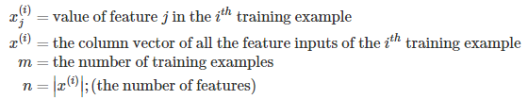

Now define the multivariable form of the hypothesis function as follows, accommodating these multiple features:

*hθ*(*x*)=*θ*0+*θ*1*x*1+*θ*2*x*2+*θ*3*x*3+⋯+*θnxn*

In order to develop intuition about this function, we can think about *θ*0 as the basic price of a house, *θ*1 as the price per square meter, *θ*2 as the price per floor, etc. *x*1 will be the number of square meters in the house, *x*2 the number of floors, etc.

Using the definition of matrix multiplication, our multivariable hypothesis function can be concisely represented as:

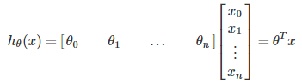

This is a vectorization of our hypothesis function for one training example; see the lessons on vectorization to learn more.

Remark: Note that for convenience reasons in this course Mr. Ng assumes *x*(*i*)0=1 for (*i*∈1,…,*m*)

[**Note**: So that we can do matrix operations with theta and x, we will set *x*(*i*)0 = 1, for all values of i. This makes the two vectors 'theta' and *x*(*i*)match each other element-wise (that is, have the same number of elements: n+1).]

The training examples are stored in X row-wise, like such:

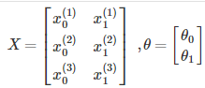

You can calculate the hypothesis as a column vector of size (m x 1) with:

*hθ*(*X*)=*Xθ*

**For the rest of these notes, and other lecture notes, X will represent a matrix of training examples***x*(*i*)**stored row-wise.**

**Cost function**

For the parameter vector θ (of type R*n*+1 or in R(*n*+1)×1, the cost function is:

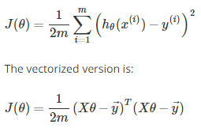

The vectorized version is:



Where *y*⃗  denotes the vector of all y values.

**Gradient Descent for Multiple Variables**

The gradient descent equation itself is generally the same form; we just have to repeat it for our 'n' features:

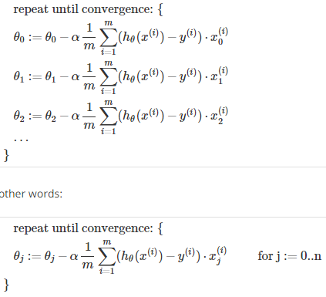

In other words:



The following image compares gradient descent with one variable to gradient descent with multiple variables:

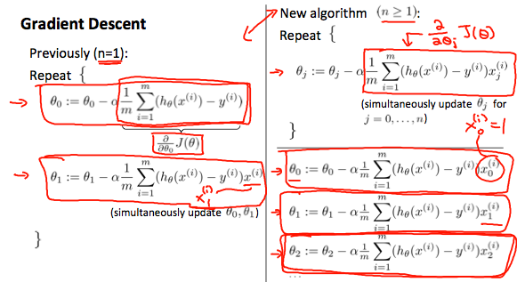

Matrix Notation

The Gradient Descent rule can be expressed as:

*θ*:=*θ*−*α*∇*J*(*θ*)

Where ∇*J*(*θ*) is a column vector of the form:

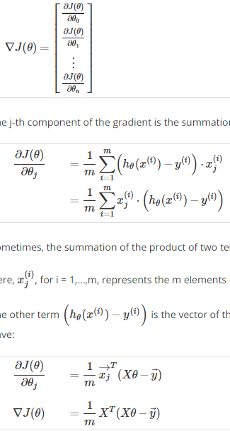

The j-th component of the gradient is the summation of the product of two terms:



Sometimes, the summation of the product of two terms can be expressed as the product of two vectors.

Here, *x*(*i*)*j*, for i = 1,...,m, represents the m elements of the j-th column, *xj*→ , of the training set X.

The other term (*hθ*(*x*(*i*))−*y*(*i*)) is the vector of the deviations between the predictions *hθ*(*x*(*i*)) and the true values *y*(*i*). Re-writing ∂*J*(*θ*)/∂*θj*, we have:



Finally, the matrix notation (vectorized) of the Gradient Descent rule is:



Feature Normalization

We can speed up gradient descent by having each of our input values in roughly the same range. This is because θ will descend quickly on small ranges and slowly on large ranges, and so will oscillate inefficiently down to the optimum when the variables are very uneven.

The way to prevent this is to modify the ranges of our input variables so that they are all roughly the same. Ideally:

−1 ≤ *x*(*i*) ≤ 1

or

−0.5 ≤ *x*(*i*) ≤ 0.5

These aren't exact requirements; we are only trying to speed things up. The goal is to get all input variables into roughly one of these ranges, give or take a few.

Two techniques to help with this are **feature scaling** and **mean normalization**. Feature scaling involves dividing the input values by the range (i.e. the maximum value minus the minimum value) of the input variable, resulting in a new range of just 1. Mean normalization involves subtracting the average value for an input variable from the values for that input variable, resulting in a new average value for the input variable of just zero. To implement both of these techniques, adjust your input values as shown in this formula:

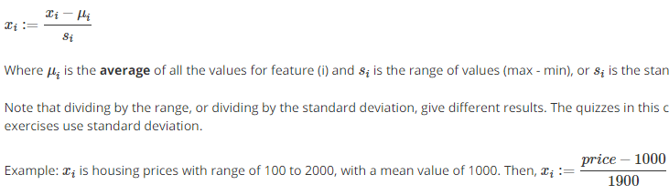

Where *μi* is the **average** of all the values for feature (i) and *si* is the range of values (max - min), or *si* is the standard deviation.

Note that dividing by the range, or dividing by the standard deviation, give different results. The quizzes in this course use range - the programming exercises use standard deviation.

Example: *xi* is housing prices with range of 100 to 2000, with a mean value of 1000. Then,



Gradient Descent Tips

**Debugging gradient descent.** Make a plot with *number of iterations* on the x-axis. Now plot the cost function, J(θ) over the number of iterations of gradient descent. If J(θ) ever increases, then you probably need to decrease α.

**Automatic convergence test.** Declare convergence if J(θ) decreases by less than E in one iteration, where E is some small value such as 10−3. However in practice it's difficult to choose this threshold value.

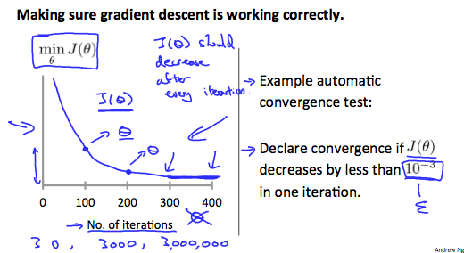

It has been proven that if learning rate α is sufficiently small, then J(θ) will decrease on every iteration. Andrew Ng recommends decreasing α by multiples of 3.

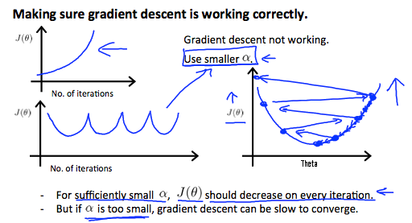

To summarize:

If *α* is too small: slow convergence.

If *α* is too large: ￼may not decrease on every iteration and thus may not converge.

Features and Polynomial Regression

We can improve our features and the form of our hypothesis function in a couple different ways.

We can **combine** multiple features into one. For example, we can combine *x*1 and *x*2 into a new feature *x*3 by taking *x*1⋅*x*2.

**Polynomial Regression**

Our hypothesis function need not be linear (a straight line) if that does not fit the data well.

We can **change the behavior or curve** of our hypothesis function by making it a quadratic, cubic or square root function (or any other form).

For example, if our hypothesis function is 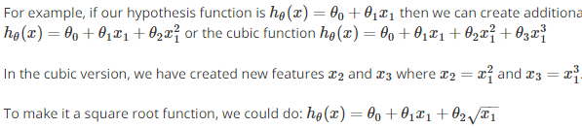 then we can create additional features based on *x*1, to get the quadratic function  or the cubic function 

In the cubic version, we have created new features *x*2 and *x*3 where 

To make it a square root function, we could do: 

Note that at 2:52 and through 6:22 in the "Features and Polynomial Regression" video, the curve that Prof Ng discusses about "doesn't ever come back down" is in reference to the hypothesis function that uses the sqrt() function (shown by the solid purple line), not the one that uses *size*2(shown with the dotted blue line). The quadratic form of the hypothesis function would have the shape shown with the blue dotted line if *θ*2 was negative.

One important thing to keep in mind is, if you choose your features this way then feature scaling becomes very important.

eg. if *x*1 has range 1 - 1000 then range of *x*12 becomes 1 - 1000000 and that of *x*13 becomes 1 - 1000000000.

Normal Equation

The "Normal Equation" is a method of finding the optimum theta **without iteration.**

Gradient descent gives one way of minimizing J. Let’s discuss a second way of doing so, this time performing the minimization explicitly and without resorting to an iterative algorithm. In the "Normal Equation" method, we will minimize J by explicitly taking its derivatives with respect to the θj ’s, and setting them to zero. This allows us to find the optimum theta without iteration. The normal equation formula is given below:



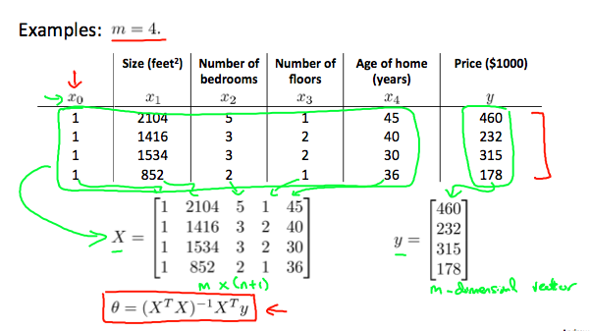

There is **no need** to do feature scaling with the normal equation.

Mathematical proof of the Normal equation requires knowledge of linear algebra and is fairly involved, so you do not need to worry about the details.

Proofs are available at these links for those who are interested:

<https://en.wikipedia.org/wiki/Linear_least_squares_(mathematics)>

<http://eli.thegreenplace.net/2014/derivation-of-the-normal-equation-for-linear-regression>

The following is a comparison of gradient descent and the normal equation:

|  |  |
| --- | --- |
| **Gradient Descent** | **Normal Equation** |
| Need to choose alpha | No need to choose alpha |
| Needs many iterations | No need to iterate |
| O (*kn*2) | O (*n*3), need to calculate inverse of *XTX* |
| Works well when n is large | Slow if n is very large |

With the normal equation, computing the inversion has complexity O(*n*3). So if we have a very large number of features, the normal equation will be slow. In practice, when n exceeds 10,000 it might be a good time to go from a normal solution to an iterative process.

**Normal Equation Noninvertibility**

When implementing the normal equation in octave we want to use the 'pinv' function rather than 'inv.'

*XTX* may be **noninvertible**. The common causes are:

* Redundant features, where two features are very closely related (i.e. they are linearly dependent)
* Too many features (e.g. m ≤ n). In this case, delete some features or use "regularization" (to be explained in a later lesson).

Solutions to the above problems include deleting a feature that is linearly dependent with another or deleting one or more features when there are too many features.

ML:Octave Tutorial

# Basic Operations

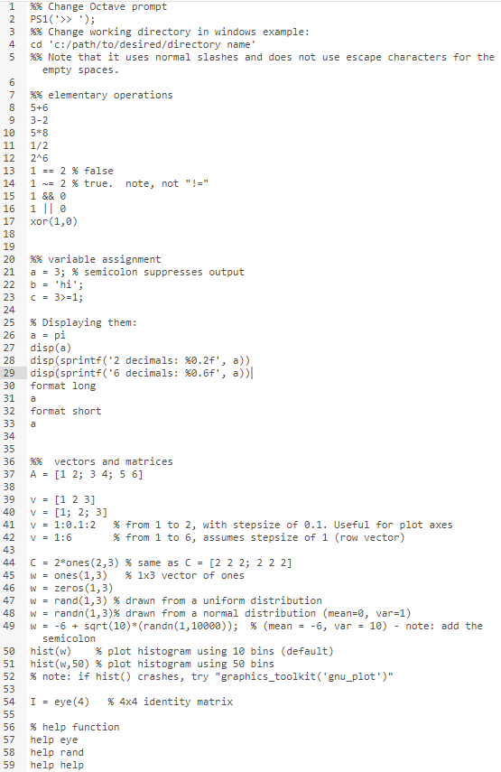

# Moving Data Around

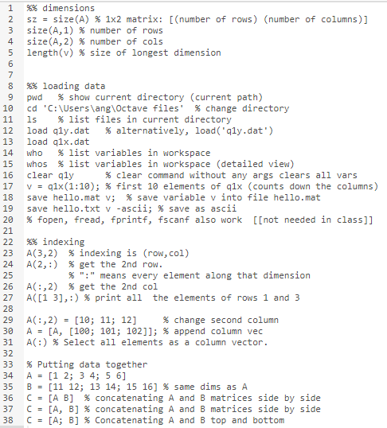

# Computing on Data

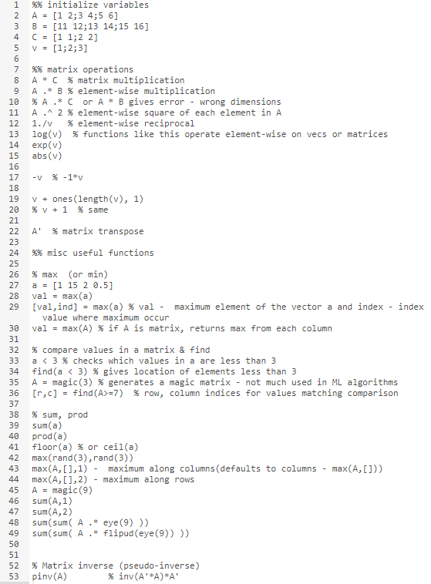

# Plotting Data

# 

# Control statements: for, while, if statements

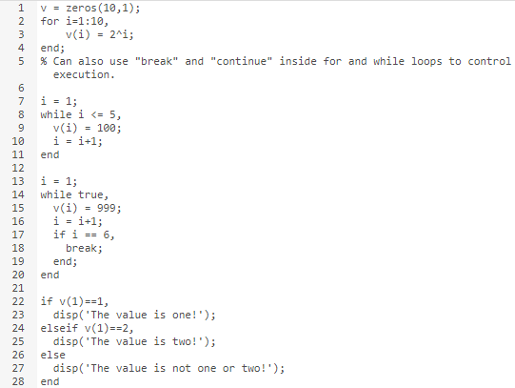

# Functions

To create a function, type the function code in a text editor (e.g. gedit or notepad), and save the file as "functionName.m"

Example function:

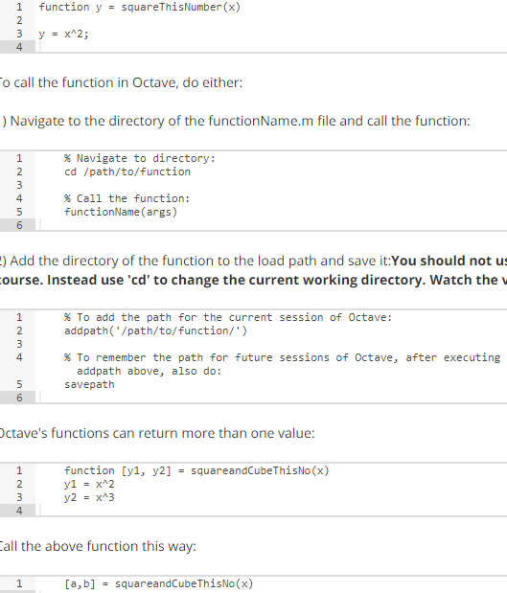

To call the function in Octave, do either:

1) Navigate to the directory of the functionName.m file and call the function:



2) Add the directory of the function to the load path and save it:**You should not use addpath/savepath for any of the assignments in this course. Instead use 'cd' to change the current working directory. Watch the video on submitting assignments in week 2 for instructions.**



Octave's functions can return more than one value:



Call the above function this way:



# Vectorization

Vectorization is the process of taking code that relies on **loops** and converting it into **matrix operations**. It is more efficient, more elegant, and more concise.

As an example, let's compute our prediction from a hypothesis. Theta is the vector of fields for the hypothesis and x is a vector of variables.

With loops:

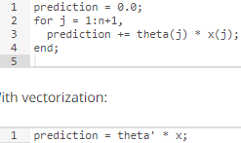

With vectorization:



If you recall the definition multiplying vectors, you'll see that this one operation does the element-wise multiplication and overall sum in a very concise notation.

If you recall the definition multiplying vectors, you'll see that this one operation does the element-wise multiplication and overall sum in a very concise notation.

# Working on and Submitting Programming Exercises

1. Download and extract the assignment's zip file.
2. Edit the proper file 'a.m', where a is the name of the exercise you're working on.
3. Run octave and cd to the assignment's extracted directory
4. Run the 'submit' function and enter the assignment number, your email, and a password (found on the top of the "Programming Exercises" page on coursera)